Background information:
Pike County Walkthrough
Document QR
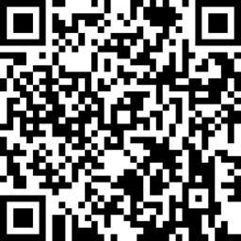
Bevins Elementary School is a small P-5 school with about 260 students. For a few years we were a Proficient school and then in 2014-15 we took a deep decline to Needs Improvement. We worked through some root causes and developed a strong plan for improvement. I am happy to say we have moved from Needs Improvement to a Distinguished school with less than a point away from being a School of Distinction in 2015-16. We contribute our success to one underlying factor - effective teaching.
This summer we were given the opportunity to participate in The Appalachian Leadership Laboratory (ALL). ALL is a project of the Kentucky Valley Educational Cooperative, made possible by a Race to the Top District (RTTT-D) grant. The mission of the Appalachian Leadership Laboratory is to build shared leadership capacity in rural teacher leaders, principals and central office administrators through innovative, personalized clinical professional learning.

What is our identified problem of practice?
Our original identified problem of practice: Teachers at Bevins Elementary strive to be accomplished in all areas of the Kentucky Framework for Teaching. According to principal walkthrough data, teachers’ individual Professional Growth Plans, and PLC discussions, the area teachers were struggling with was 3C: Engaging Students in Learning. Teachers were engaging their students in learning on a regular basis, but data showed they were not “actively and authentically engaged in meaningful, rigorous work aligned with the standards” as the district walkthrough document noted. Through PLC discussions, teachers discussed ways to improve their performance in this domain, but were lacking the knowledge and strategies needed for authentic student engagement.
Theory of Action QR
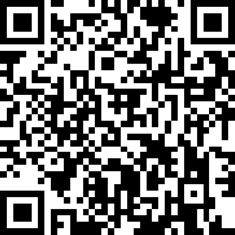
What was our plan of action?
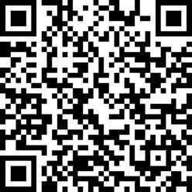
We developed a plan of action for what our district leadership, principal, teachers, and students would do and results we hoped to achieve. We created a data collection document to collect real time walkthrough data. Throughout the school year, the walkthrough data grew to be a tool for improvement for instruction in our school in all areas rather than just active engagement. Our problem of practice shifted to become more about improving instruction in all areas noted on the walkthrough instrument.
Walkthrough
Collector QR

What progress have we made?
PLC discussions created a sense of urgency with the teachers to improve their instructional practices. Teachers created a bank of strategies for each of the areas on the walkthrough document to share during PLCs. Teachers also reviewed their walkthrough feedback and developed plans for improving areas of weakness. The results allowed us to personalize professional learning for the teachers. Our district makes use of Non-Traditional Instructional Days. Teachers report to school for 4 hours on these days so we made use of this time to design professional development around the areas of need.
- Since active engagement was the focus of our original problem of practice, we sent two teachers and the principal to a Kagan Cooperative Learning training. Also, two teachers were involved with training at the district level by PIMSER on student engagement. The teachers came back and trained the staff after school and through PLCs. In September our average score on walkthrough data for active engagement was a 2.1 and by November we climbed to a 2.7 and this average has remained constant through the present month.
- Based on the walkthrough collection data, we noticed that learning target scores dropped drastically. We collaborated with the School Leadership Team and concluded the reason might be because our district changed the walkthrough instrument and added success criteria. To be sure that our teachers understood what is expected in the area of learning targets, we created a one-page organizer and asked teachers to bring one learning target from the week to the next vertical PLC. We had them work through the organizer one at a time with the learning target. This took about a month for teachers to be able to work through the organizer with their colleagues. Together the teachers looked at if the target aligned to the standards and the Pike County Curriculum Document. They looked to see if the activity of the day aligned to the target. They had discussions on if the target student friendly and rigorous and what evidence proved so. They had deep discussion on how the target might be used to drive instruction. After spending a great deal of time on learning targets in the PLC, the averages for this area of the walkthrough increased again. The average for December was 2.6 and climbed to 2.9 in January.
- Formative Assessment is an area where the average score ranged from 1.8 – 2.7. The principal used the book, Emdedded Formative Assessment, to create a professional learning and activities to lead the teachers through on the various NTI Days. In October, our average score on the walkthrough for formative assessment was a 1.8 and by March the average raised to a 2.6.
- From looking at the data, we wanted to make sure there was cohesiveness with the walkthrough document. Our principal and the other area schools (three elementary, one middle, and one high school) organized and conducted walkthroughs in each other schools.
What our future plans?
- Continue with personalized professional learning and district wide professional development
- Use walkthrough data to drive PLC discussions and develop professional growth goals
- Tailored peer observations
- Teachers will continue to build a toolbox of strategies for each domain of the walkthrough
- Continue area wide walkthroughs
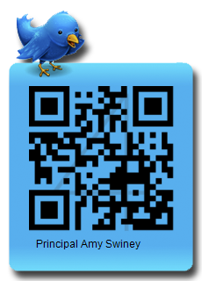
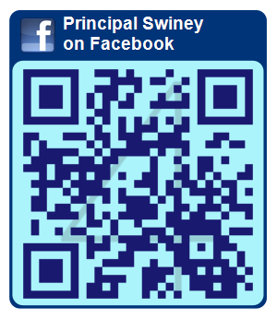
Ways to contact us:
Email: Danielle.Masters@Pike.kyschools.us
Email: Amy.Swiney@Pike.Kyschools.us
Facebook Twitter
Twitter

